Computer Organization and Assembly Language


Coal CCP
Submitted to: Sir Muhammad Khalid
Submitted by: Javeria Khurshid
Roll no: 24-CS-058
Section: C

HITEC university, Taxila
Department of computer science

Resource Management System for Remote Areas
Course Title: CS-207 Computer Organization & Assembly Language
- PROJECT OVERVIEW
This project addresses a Complex Computing Problem (CCP) involving resource distribution in internet-deprived remote areas. Given the hardware constraints of edge devices like the Raspberry Pi (limited memory and storage), this solution utilizes x86 Assembly Language (8086) to create a highly efficient, low-level database system. The system manages vital records for food and water distribution, ensuring that resource allocation is tracked accurately without the overhead of modern, high-level database engines.
- PROBLEM ANALYSIS (CEP ATTRIBUTES)
To meet the requirements of a Complex Computing Problem, the following attributes were considered:
- Memory Efficiency: Assembly language was chosen to minimize the footprint on limited-resource hardware.
- Data Integrity: The system implements logic to prevent duplicate "Serial Numbers" (Sr#) to ensure record uniqueness.
- Arithmetic Operations: The program calculates real-time "Grand Totals" for all resources (Water, Flour, Pulses) using 16-bit registers.
- User Conflict Management: Functions for Adding, Updating, and Removing records provide a full CRUD (Create, Read, Update, Delete) cycle within a low-level environment.
- SYSTEM FEATURES
The Resource Management System is designed with a modular approach. Below are the core functionalities implemented in the code:
- Unique Record Entry: Users can add records (Name, Family Members, Water, Flour, Pulses). The system scans existing IDs to prevent duplicates.
- Dynamic Record Update: Allows modification of existing data. It automatically adjusts the global totals by subtracting old values and adding new ones.
- Record Removal with Memory Shifting: When a record is deleted, the system shifts subsequent data in the array to maintain a contiguous memory block.
- Data Visualization: Displays a formatted table including a "Grand Total" row for resource planning.
- TECHNICAL IMPLEMENTATION DETAILS
A. Data Structure and Memory Mapping
The system uses parallel arrays to simulate a database table. This is more memory-efficient in Assembly than complex structures:
- list_id, list_mem, list_wat, etc., store numeric data in byte-sized increments.
- list_names uses a 10-byte fixed-width allocation per entry to allow for predictable memory offset calculations ($Index \times 10$).
B. Algorithmic Logic
- Duplicate Check: Before saving a new record, the system uses a loop to compare the temp_id against the list_id array.
- Totaling (Summation): As data is entered or removed, the variables sum_mem, sum_wat, etc., are updated using ADD and SUB instructions to avoid re-calculating the entire list every time.
- The Removal Logic: To remove a record at index i, the program performs a manual shift: $Array[i] = Array[i+1]$. This ensures the database remains compact.

- CODE LOGIC BREAKDOWN (MODULES)
Module | Description
Main Loop | Handles the menu selection and directs the program flow using CMP and JE instructions.
Input Proc | Captures keystrokes, converts ASCII to numeric values, and handles the "Enter" key buffer.
Output Proc | Formats the screen, prints strings, and converts numeric totals back to ASCII for display.
Update/Remove | Implements search algorithms to find specific Serial Numbers before performing operations.
- OUTPUT
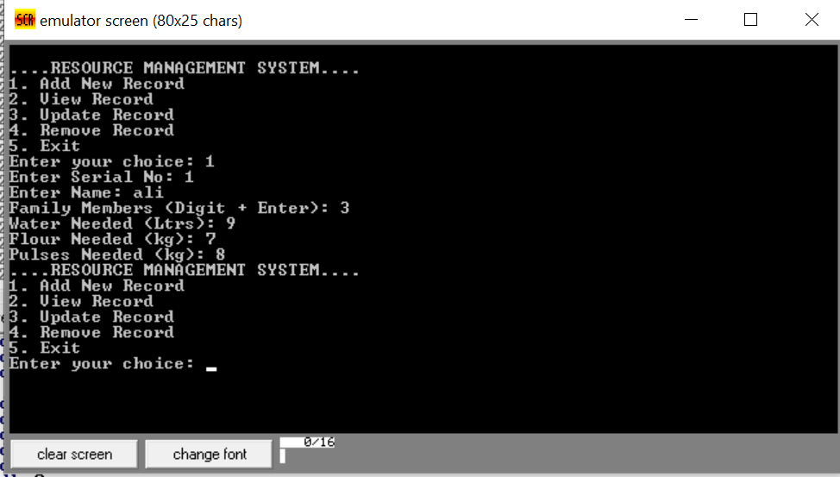
Adding a Record
- Selection: The user chooses Option 1 from the menu to add data.
- Identification: A unique Serial Number is entered to identify the household.
- Data Entry: Information such as Name, Family Size, and Resource Needs (water/flour/pulses) is collected.
- Calculation: The system automatically adds these values to the Grand Totals for the region.
- Completion: The program saves the data to memory and returns to the Main Menu.
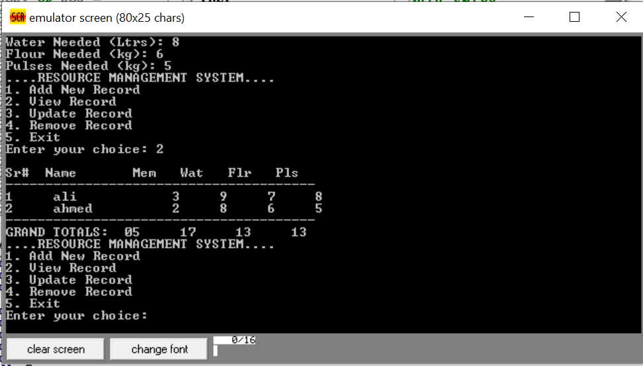

Data Entry and Resource Summary
- Action: The user selects Option 1 to input a new record and Option 2 to display the current database.
- Data Collection: Information for individuals like "ali" and "ahmed" is recorded, including their Serial Number, Family Members, and specific consumption of Water, Flour, and Pulses.
- Storage: Each entry is saved into a structured list within the program's memory.
- Automatic Totals: The system automatically calculates Grand Totals for the entire area, providing a final tally of all resources needed for the listed population.
- Formatted Display: When viewing, the program organizes the data into a clear table with headers and a summary line for total consumption.
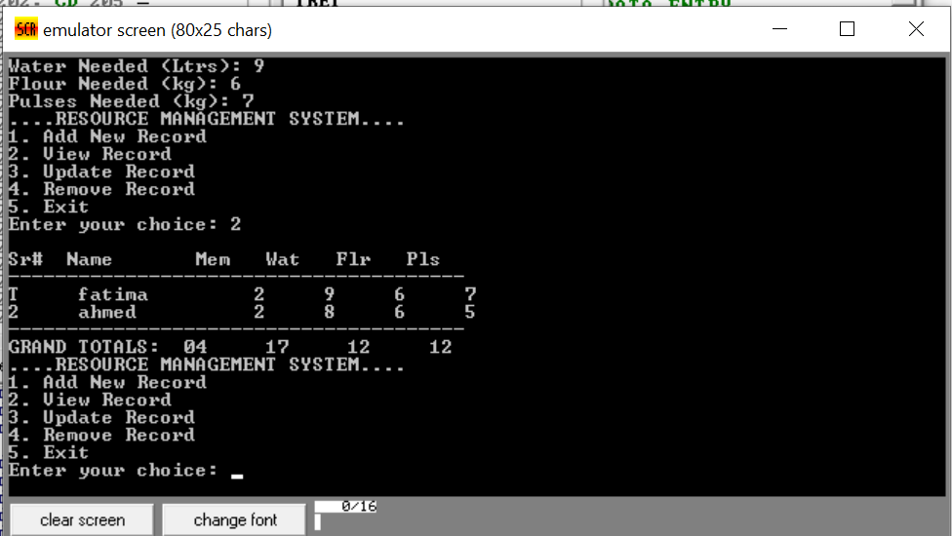

Updated Resource Summary
- Modification: The user selects Option 3 to update an existing record, changing specific resource values for a household.
- Data Refresh: The system overwrites the old data in memory with the new entries for family members and consumption levels.
- Recalculation: The Grand Totals are automatically adjusted by subtracting the old values and adding the new ones.
- Table View: Selecting Option 2 displays the updated table, showing the current state of resources for individuals like "fatima" and "ahmed."
- Final Tally: The summary row provides the new, accurate totals for the entire region's Water, Flour, and Pulses needs.
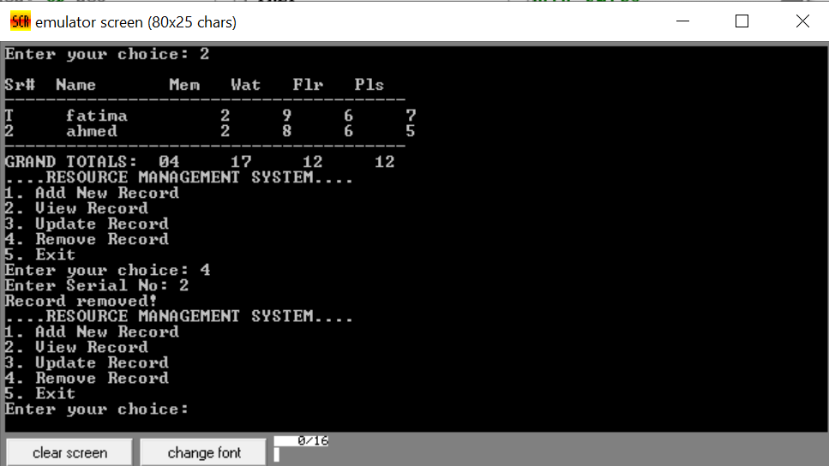
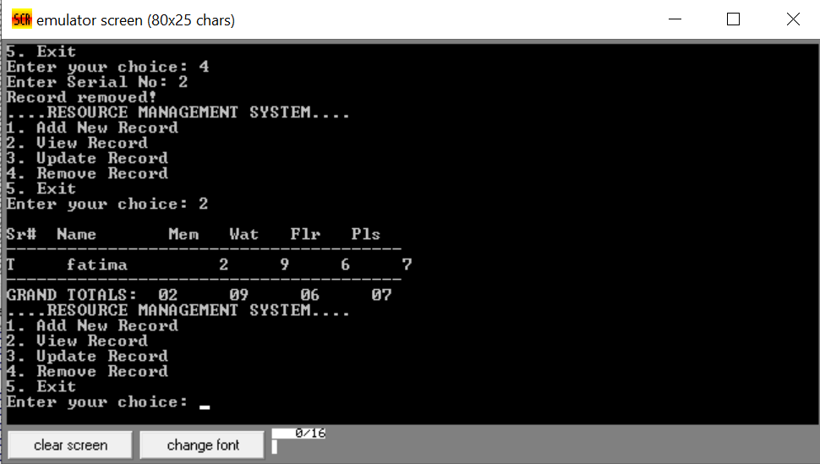
Removing Records: Option 4 allows the user to delete a specific entry by its Serial Number, which automatically updates the list and adjusts all totals.
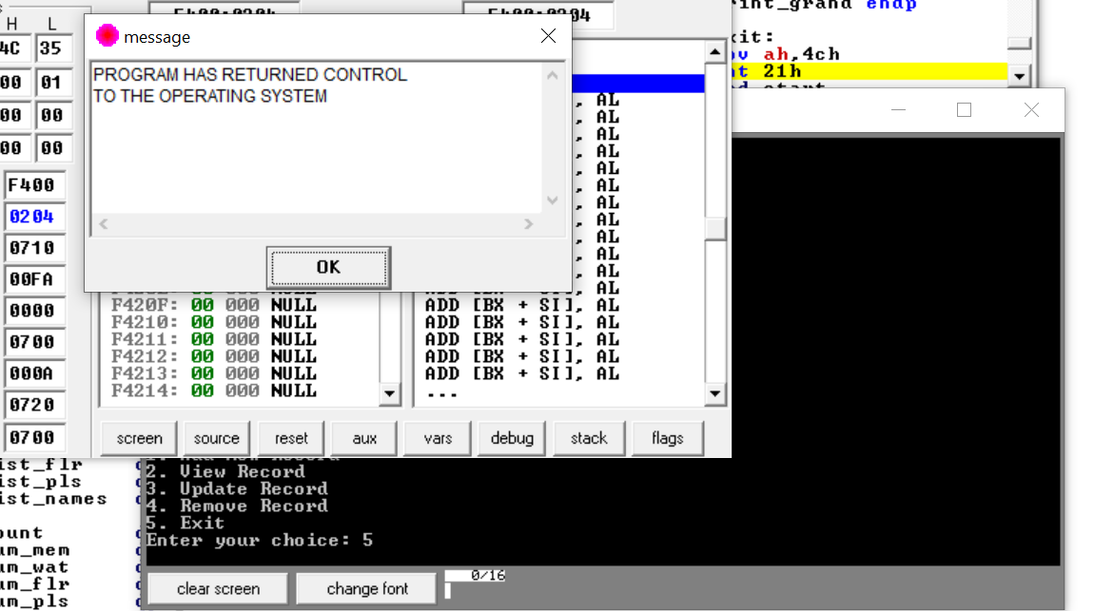
Termination: Selecting Option 5 safely ends the program and returns control to the operating system.
- CONCLUSION
This project successfully demonstrates the use of Assembly Language to solve real-world logistical problems under hardware constraints. By managing memory at the register level and implementing custom logic for data validation and arithmetic, the system provides a robust solution for resource management in remote areas. It fulfills the CO3 objective by applying addressing modes and arithmetic operations to solve complex data problems.

